Lab 3
KNN ALGORITHM
import numpy as np
from sklearn.datasets import load_diabetes
from sklearn.model_selection import train_test_split
from sklearn.preprocessing import StandardScaler
from sklearn.neighbors import KNeighborsRegressor
from sklearn.metrics import r2_score

# Load dataset
diabetes = load_diabetes()
X = diabetes.data
y = diabetes.target

# Display dataset range
print("Diabetes Progression Value Range:")
print("Minimum value :", np.min(y))
print("Maximum value :", np.max(y))

# Threshold (mean value)
threshold = np.mean(y)
print("Mean (Threshold) Value :", threshold)

# Split dataset
X_train, X_test, y_train, y_test = train_test_split(
X, y, test_size=0.2, random_state=42)

# Feature scaling
scaler = StandardScaler()
X_train = scaler.fit_transform(X_train)
X_test = scaler.transform(X_test)

# Train model for k = 2 to 5
print("\nModel Performance:")
for k in range(2, 6):
model = KNeighborsRegressor(n_neighbors=k)
model.fit(X_train, y_train)
pred = model.predict(X_test)
print(f"K = {k}, R2 Score = {r2_score(y_test, pred):.4f}")

# -------------------------------
# Predict for a given datapoint
# -------------------------------

# Example: Take first test sample
given_datapoint = X_test[0].reshape(1, -1)

# Use k = 3 for final prediction
final_model = KNeighborsRegressor(n_neighbors=3)
final_model.fit(X_train, y_train)

prediction = final_model.predict(given_datapoint)[0]

print("\nGiven Data Point:")
print(given_datapoint)

print("\nPredicted Diabetes Progression Value:", prediction)

# Decision based on threshold
print("\nDecision:")

if prediction > threshold:
print(f"Since {prediction:.2f} is greater than threshold ({threshold:.2f}),")
print("The person HAS significant diabetes progression.")
else:
print(f"Since {prediction:.2f} is less than threshold ({threshold:.2f}),")
print("The person does NOT have significant diabetes progression.")

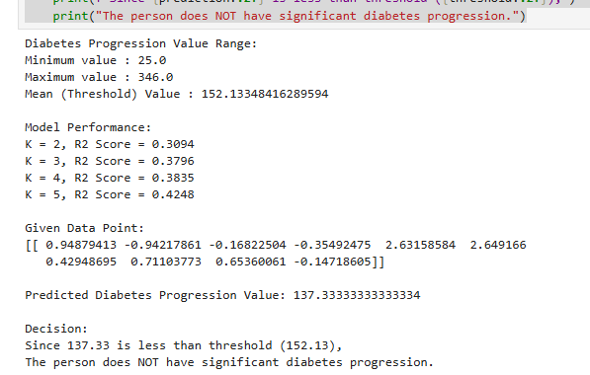

2. Multiple linear regression

import numpy as np
from sklearn.datasets import fetch_california_housing
from sklearn.model_selection import train_test_split
from sklearn.linear_model import LinearRegression
from sklearn.metrics import r2_score

# -----------------------------
# Step 1: Load Dataset
# -----------------------------
housing = fetch_california_housing()
X = housing.data
y = housing.target
feature_names = housing.feature_names

# -----------------------------
# Step 2: Split Dataset
# -----------------------------
X_train, X_test, y_train, y_test = train_test_split(
X, y, test_size=0.2, random_state=42)

# -----------------------------
# Step 3: Train Model
# -----------------------------
model = LinearRegression()
model.fit(X_train, y_train)

# -----------------------------
# Step 4: Model Performance
# -----------------------------
y_pred = model.predict(X_test)
print("Model R2 Score:", r2_score(y_test, y_pred))

# -----------------------------
# Step 5: Predict for One Data Point
# -----------------------------
sample = X_test[0]
prediction = model.predict(sample.reshape(1, -1))[0]

print("\n------ HOUSE DETAILS ------")
for name, value in zip(feature_names, sample):
print(f"{name} : {value}")

print("\n------ PREDICTION RESULT ------")
print(f"Predicted House Price: ${prediction * 100000:.2f}")
print(f"Actual House Price : ${y_test[0] * 100000:.2f}")

difference = abs(prediction - y_test[0])
print(f"Difference : ${difference * 100000:.2f}")

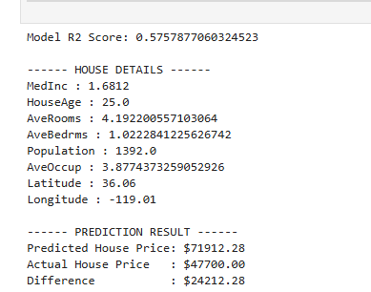

LINEAR REGRESSION:
Code:
import pandas as pd
from sklearn.datasets import fetch_california_housing
from sklearn.model_selection import train_test_split
from sklearn.linear_model import LinearRegression
from sklearn.metrics import mean_squared_error, r2_score

# ----------- LOAD DATASET -----------
housing = fetch_california_housing()
df = pd.DataFrame(housing.data, columns=housing.feature_names)
df['Price'] = housing.target

# ----------- DEFINE FEATURES & TARGET -----------
X = df.drop('Price', axis=1)
y = df['Price']

# ----------- TRAIN-TEST SPLIT -----------
X_train, X_test, y_train, y_test = train_test_split(X, y, test_size=0.2, random_state=42)

# ----------- MODEL TRAINING -----------
model = LinearRegression()
model.fit(X_train, y_train)

# ----------- PREDICTION -----------
y_pred = model.predict(X_test)

# ----------- EVALUATION -----------
mse = mean_squared_error(y_test, y_pred)
r2 = r2_score(y_test, y_pred)

print("Mean Squared Error:", mse)
print("R2 Score:", r2)

